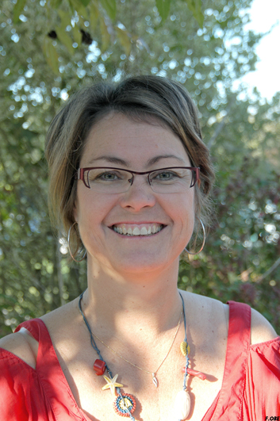 | Virginie Gandemer, MD-PhD  Head of department of Pediatric Oncology and Hematology  Professor of University Rennes 1  CHU Hôpital Sud- 16 Bd de Bulgarie - 35203 Rennes Cedex 2  Phone : (33) 2 99 26 58 35 – Fax : (33) 2 99 26 71 95  Email : virginie.gandemer@chu-rennes.fr

- MD and paediatrician (1994), France
- PhD (2007) in Biology and Medical Sciences with Research Director Degree (2010),
and Professor of paediatrics (2011) , University RENNES 1
- Associate Research Worker from 2007 in Gene Expression Oncogenesis Team, UMR6290 CNRS, France University Rennes 1, France

- Principal Investigator for Philadelphia acute lymphoblastic leukemia in France and member of the European task Force of the EsPhALL group
- Member of SIOP, ASH, EBMT and IBFM
- Founder and president of the shared care network in brittany since 1999
- President of the scientific council of the pediatric hemato-oncology network of the west part of France since 2010
- Secretary of the executive committee of the Société Française de Lutte Contre les Cancers et Leucémies de l’Enfant et l’Adolescent (SFCE) from 2011
Five recent significant publications

- J. Bonneau, J. Lebreton, S. Taque, C. Chappé, C. Edan, S. Bayart, E. Le Gall, V. Gandemer
School performance of childhood cancer survivors: mind also the teenagers!
J Pediatr 2011 Jan;158(1):135-41.
- V. Gandemer, S. Chevret, A. Petit, C. Vermylen, T. Leblanc, G. Michel, C. Schmitt, O. Lejars, P. Schneider, F. Demeocq, B. Bader-Meunier, F. Bernaudin, Y. Perel, MF. Auclerc, JM. Cayuela, , G. Leverger and A. Baruchel on behalf of the FRALLE group
Excellent prognosis of late relapses of ETV6/RUNX1-positive childhood acute lymphoblastic leukemia: lessons from the FRALLE 93 protocol
Haematologica . 2012 Nov;97(11):1743-50.
- A. Biondi, M. Schrappe, P. De Lorenzo, A. Castor, G. Lucchini, V. Gandemer, R. Pieters, J. Stary, G. Escherich, M. Campbell, CK. Li, A. Vora, M. Aricò, S. Röttgers, V. Saha, MG. Valsecchi

Imatinib after induction for treatment of children and adolescents with Philadelphia chromosome-positive acute lymphoblastic leukaemia (EsPhALL): a randomised, open-label, intergroup study.
Lancet Oncol. 2012 Sep;13(9):936-45
- Daikeler T, Labopin M, Ruggeri A, Crotta A, Abinun M, Hussein AA, Carlson K, Cornillon J, Diez-Martin JL, Gandemer V, Faraci M, Lindemans C, O'Meara A, Mialou V, Renard M, Sedlacek P, Sirvent A, Socié G, Sora F, Varotto S, Sanz J, Voswinkel J, Vora A, Yesilipek MA, Herr AL, Gluckman E, Farge D, Rocha V.
New autoimmune diseases after cord blood transplantation: a retrospective study of EUROCORD and the Autoimmune Disease Working Party of the European Group for Blood and Marrow
Transplantation.
Blood. 2013 Feb 7;121(6):1059-64. doi: 10.1182/blood-2012-07-445965. Epub 2012 Dec 17.
- V. Gandemer, C. Pochon, E. Oger, JH. Dalle, G. Michel, C. Schmitt, E.de Berranger, C. Galambrun, H. Cavé, JM. Cayuela, N. Grardel, E.Macintyre, G. Margueritte, F. Méchinaud, P. Rorhlich, P. Lutz, F. Demeocq, P. Schneider, D. Plantaz, M. Poirée and P. Bordigoni
Clinical value of pre-transplant minimal residual disease in childhood lymphoblastic leukaemia: the results of the French MRD-guided protocol
Br J Haematol 2014 May;165(3):392-401

